

**A REPORT OF MINOR PROJECT**

**ON**

**BHARTI AIRTEL**

**SUBMITTED BY**

**JAYANT DWIVEDI**

**190901144**

**BACHELORS OF BUSINESS ADMINISTRATION**

**UNDER THE GUIDANCE OF**

**Dr SONAL SIDANA**

**ASSISTANT PROFESSOR**



**SCHOOL OF BUSINESS AND COMMERCE**

**MANIPAL UNIVERSITY JAIPUR**

**CONTENTS**

|  |  |  |
| --- | --- | --- |
| **Sr. No.** | **Title** | **Page No.** |
| 1. | INTRODUCTION ABOUT COMPANY | 3 |
| 2. | COMPANY STRUCTURE | 4-5 |
| 3. | PRODUCTS & SERVICES OF THE COMPANY | 6-7 |
| 4. | COMPETITORS OF THE COMPANY | 8-10 |
| 5. | MARKET POSITION OF THE COMPANY | 11-12 |
| 6. | SWOT ANALYSIS | 13-15 |
| 7. | CONCLUSION | 16 |
|  | BIBLIOGRAPHY & REFERENCING |  |

**INTRODUCTION ABOUT COMPANY**

Bharti Airtel Ltd. a global telecommunication company operates in 16 countries with major presence in Asia and Africa. With 413 million subscribers, the company is among top three global mobile service providers (Annual17-18, 2019). The company is headquartered in India and there it offers wireless services, cell phone commerce, internet, DTH (Anita Rajitha and M, 2018). The company covers almost 95.3% Indian population. The company presents itself with brand name “Airtel” (Annual17-18, 2019).

The telecommunication industry in India has taken a disruptive trend in Green Telecom, Expansion to Rural Areas, launch of BWA Technologies, Internet of things, increase in investment, mobile banking and more (Airtel Website, n.d.). These trends have brought rising competition and hence, to serve the large consumer base, the companies have to take in more debt burden and high operating cost. Airtel has brought in a certain set of mission and Goals to build and maintain its existing market share (India Brand Equity Foundation, 2017).

“**Our vision is to enrich the lives of customers. Our obsession is to win customers for life through an exceptional experience**” (Annual17-18, 2019).

The disruptive trend discussed in current scenario of telecommunication industry has created huge amount of turbulence for Airtel. Its Profits have fallen and debts have increased (Annual17- 18, 2019). It has to go for continuous tariff plan price revisions and establish new strategies to fight heavily competitive landscape (Bushes, 2018). Hence, we look into external and internal environment, capabilities of the company, which push it towards the corporate and business strategies taken to curb current market challenges. We use secondary sources, relevant models and theories to investigate and build recommendations.

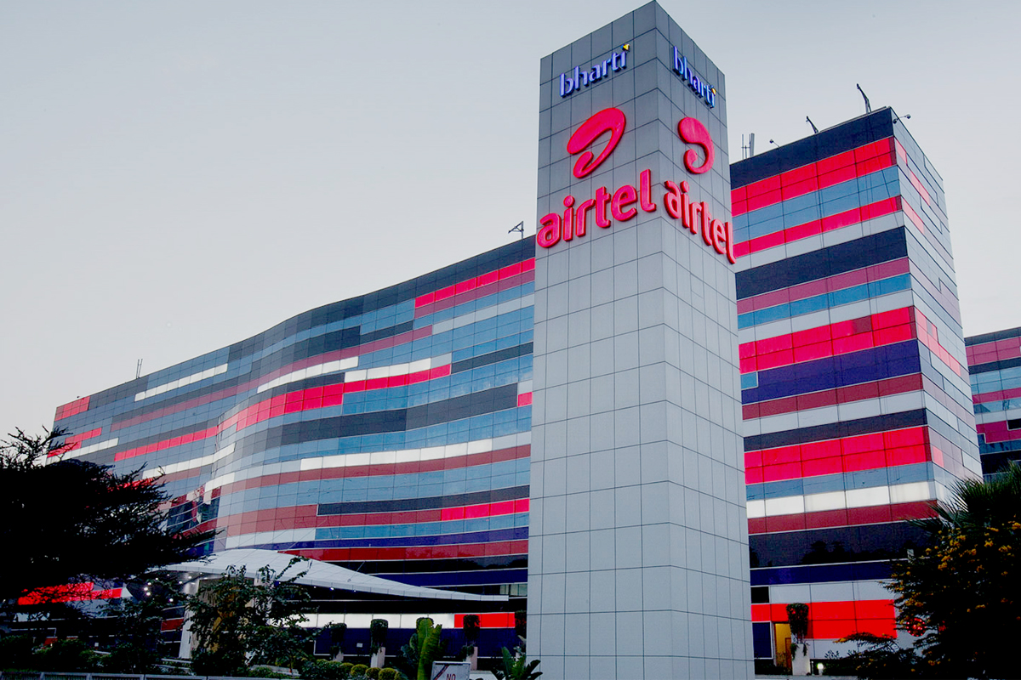

**COMPANY STRUCTURE**

With effect from Jan 13, 2010 a new integrated organizational structure has emerged with an objective to enhance Airtel focus on expanding operations in international markets beyond India and South Asia and further consolidate its leadership position in India. The transformed organizational structure consists of two distinct Customer Business Units (CBU) with clear focus on B2C (Business to Customer) and B2B (Business to Business) segments. Bharti Airtel’s B2C business unit comprehensively serves the retail consumers, homes and small offices, by combining business units such as Mobile, Telemedia, Digital TV and other emerging businesses (like M-commerce, M-health, M-advertising etc.). The B2C organization encompasses Consumer Business and Market Operations. Bharti Airtel has understood the importance of its partners to remain competitive in a dynamic business environment. As a step in that direction, the Supply Chain (SCM) function has been created with a mandate to develop partner relationships to maximize mutual opportunities for growth and profitability. The SCM organization has a central core team of supply chain subject matter experts and execution teams operating under different business divisions across the country.

Airtel is probably one of the best run companies in India. It has advantages of both having a massive size and being in a very high growth industry. The secret of its enormous success owes a lot to its business model. Airtel focuses solely on two things: Customer acquisition & Servicing and business development/Expansion. The main focus of Airtel has been on Data IP solutions, conferencing and Video solutions and wants to grab the potential of market of these business sectors. The other functions such as hardware, network, backend applications (billing etc), value added services and even telecom infrastructure are all outsourced. Airtel was the first player in India in pioneering such business model. Airtel has outsourced its Network Management services to players like Nokia Siemens and Ericson, while its backend application is taken care by IBM.  It was also the first to divest its hard assets, i.e. – its telecom towers – to a separate company and lease them back themselves as well as monetize surplus bandwidth by selling to other operators.

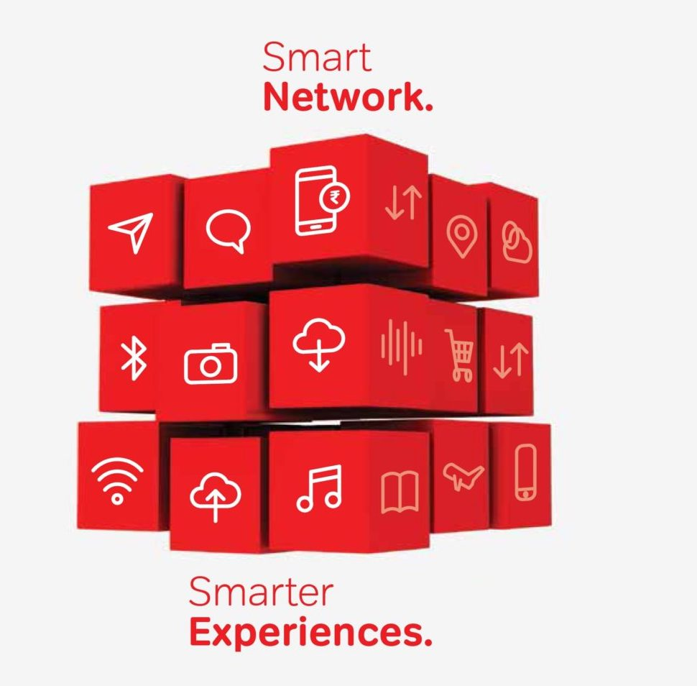

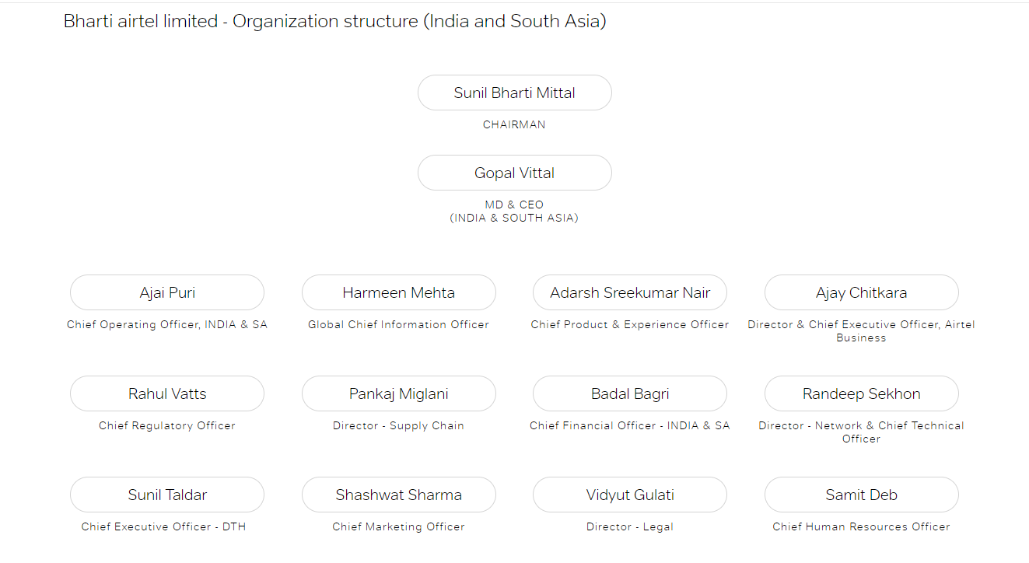



**PRODUCTS AND SERVICES OF COMPANY**

**INTERNET LEASED LINE (ILL):**

A **leased line** is a systematic telecommunications line connecting two locations. It is sometimes known as ‘private circuit’ or ‘data line’. Unlike traditional PSTN lines it does not have a telephone number, each side of the line being permanently connected to other. Leased lines can be used for telephone, data or internet services. Leased lines are usually available at speed of 512 kbps, 1 mbps, and 2 mbps and so on.

**MULTI PROTOCAL LABEL SWITCHING (MPLS):**

MPLS is a high-performance method for forwarding packets through a network. It enables routers at the edge of a network to apply simple labels of packet. ATM switches or existing routes in the network core can switch packets according to the labels with minimal lookup overhead. MPLS networks deliver enterprise scale connectivity deployed on a shared infrastructure with the same policies enjoyed in a private network.

**VIRTUAL PRIVATE NETWORK (VPN): -**

VPN is a network that uses a public telecommunication infrastructure, such as the Internet, to provide remote offices or individual users with secure access to their organization’s network.

Instead of using dedicated connection, such as leased-line direct circuits, the VPN option uses tunnels routed over the Internet from the company’s private network to another location on the company’s network. While relatively secure, VPNs are subject to latency and security issues inherent in using the public Internet as a transport device for private data.

**INTERNATIONAL PRIVATE LEASED CIRCUIT (IPLC): -**

An IPLC is a point-to-point private line used by an organization to provide state-of-the-art connectivity between offices that are located across various countries. It provides dedicated bandwidth for data transmission in India and abroad. Connectivity is providing cable systems like i2i, TIC, SMW4 and SMW3.

VERY SMALL APERATURE TECHNOLOGY (VSAT): -

VSAT enables telecommunications amongst offices situated at distant and remote places via satellites. It provides maximum transponder bandwidth space from multiple satellites. VSAT has multiple operational hubs in India on multiple technology platforms.

**Mobile**

Experience total cost control, no rentals and easy billing with our post-paid and prepaid services. Explore the

world with our roaming services and get absolutely cool offers with Airtel Live.

**Prepaid**

Enter the world of limitless possibilities with Airtel Prepaid. The service that helps you give words to every feeling, an expression to every emotion.

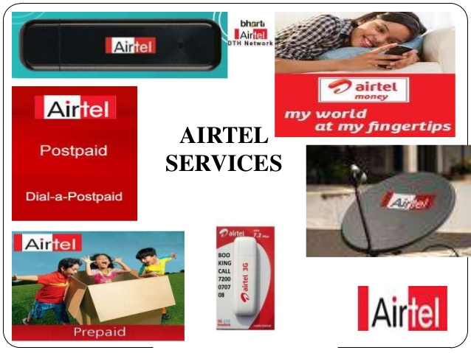

**Post-paid**

Life becomes much simpler with your Airtel Postpaid. It gives you the unlimited freedom to reach out to

people in your special way.

**Home Phones**

Experience a world class service and cutting-edge technology with Airtel landline and our feature rich

Wireless fixed line. What’s more, calling is made more fun and convenient with services and entertainment on Airtel

**Fixed Line**

Airtel welcomes you to its world of telephony services, which offers you world class services with its cutting-edge technology.

**Fixed Wireless Phone**

Avail of the convenience of a mobile phone on a fixed line, without any cables disturbing the ambience of your living room!

**Broadband and Internet**

Experience a world class service and cutting-edge technology with Airtel landline and our feature rich

Wireless fixed line. What’s more, calling is made more fun and convenient with services and entertainment on Airtel.

**Wi-Fi**

One Airtel Offer Power of 16 Mbps, IPTV Airtel Net PC, Airtel PC Security.

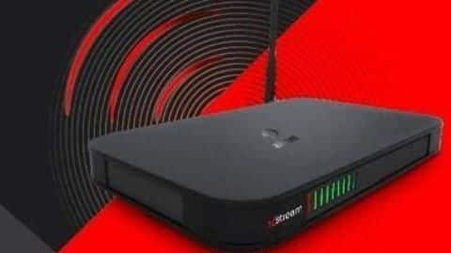

**COMPETITORS OF THE COMPANY**

**Mahanagar Telephone Nigam Ltd.**



Mahanagar Telephone Nigam Limited,  MTNL, is a [state-owned](https://en.wikipedia.org/wiki/Government-owned_corporation) telecommunications service provider and wholly owned subsidiary of [BSNL](https://en.wikipedia.org/wiki/BSNL) headquartered in New Delhi, India. MTNL Provides services in the metro cities of [Mumbai](https://en.wikipedia.org/wiki/Mumbai) and [New Delhi](https://en.wikipedia.org/wiki/New_Delhi) in [India](https://en.wikipedia.org/wiki/India) and in the island nation of [Mauritius](https://en.wikipedia.org/wiki/Mauritius) in [Africa](https://en.wikipedia.org/wiki/Africa). The company had a [monopoly](https://en.wikipedia.org/wiki/Monopoly) in Mumbai and New Delhi until 1992, when the telecom sector was opened to other service providers. "Transparency makes us different" is the motto of the company. The [Government of India](https://en.wikipedia.org/wiki/Government_of_India) currently holds 57% stock in the company with the rest being held by public and institutional investors. The company's shares are listed on [Bombay Stock Exchange](https://en.wikipedia.org/wiki/Bombay_Stock_Exchange), [Global depository receipts](https://en.wikipedia.org/wiki/Global_depository_receipt) on [London Stock Exchange](https://en.wikipedia.org/wiki/London_Stock_Exchange) and [American depository receipts](https://en.wikipedia.org/wiki/American_depository_receipt) on [New York Stock Exchange](https://en.wikipedia.org/wiki/New_York_Stock_Exchange). As of March 2020, it has 3.35 million subscribers. It is also a public sector enterprise of Navratna status which is given by Government of India to the best performing state-owned companies.

**Reliance Jio Info COMM Limited**



Reliance Jio Info COMM Limited, Jio, is an Indian [telecommunications](https://en.wikipedia.org/wiki/Telecommunications) company and a subsidiary of [Jio Platforms](https://en.wikipedia.org/wiki/Jio_Platforms), headquartered in [Mumbai](https://en.wikipedia.org/wiki/Mumbai), [Maharashtra](https://en.wikipedia.org/wiki/Maharashtra), [India](https://en.wikipedia.org/wiki/India). It operates a national [LTE](https://en.wikipedia.org/wiki/LTE_(telecommunication)) network with coverage across all 22 [telecom circles](https://en.wikipedia.org/wiki/Telecom_circle). It does not offer [2G](https://en.wikipedia.org/wiki/2G) or [3G](https://en.wikipedia.org/wiki/3G) service, and instead uses only [voice over LTE](https://en.wikipedia.org/wiki/Voice_over_LTE) to provide voice service on its 4G network.

Jio soft launched on 27 December 2015 with a beta for partners and employees, and became publicly available on 5 September 2016. As of 31 December 2019, it is the [largest mobile network operator in India](https://en.wikipedia.org/wiki/List_of_telecom_companies_in_India#Wireless_Operators) and the [third largest mobile network operator in the world](https://en.wikipedia.org/wiki/List_of_mobile_network_operators#Terrestrial) with over 40.56 [crore](https://en.wikipedia.org/wiki/Crore) (405.6 million) subscribers.

In September 2019, Jio launched a [fiber to the home](https://en.wikipedia.org/wiki/Fiber_to_the_home) service, offering home broadband, television, and telephone services. Since April 2020, [Reliance Industries](https://en.wikipedia.org/wiki/Reliance_Industries) has raised ₹152,056 crore (US$21 billion) by selling 32.97% equity stake in Jio Platforms.

**Vodafone Idea Ltd**.

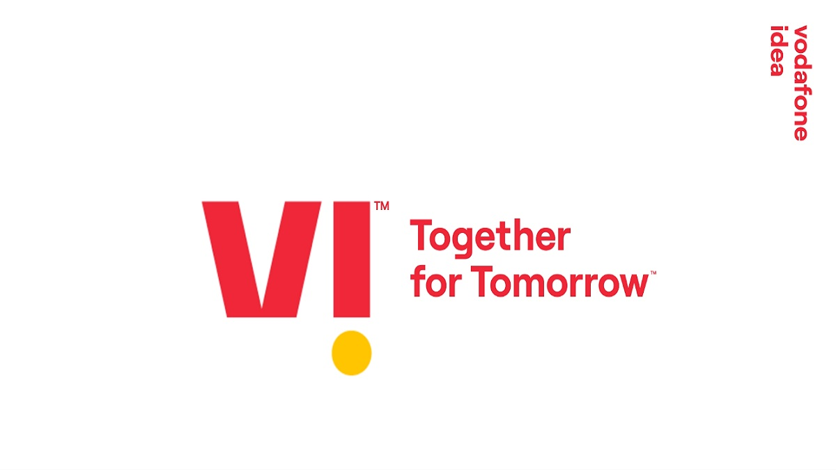

Vodafone Idea Limited,  Vi (pronounced [/wiː/](https://en.wikipedia.org/wiki/Help:IPA/English)) is an Indian telecom operator with its headquarters based in [Mumbai](https://en.wikipedia.org/wiki/Mumbai), [Maharashtra](https://en.wikipedia.org/wiki/Maharashtra) and [Gandhinagar](https://en.wikipedia.org/wiki/Gandhinagar), [Gujarat](https://en.wikipedia.org/wiki/Gujarat) in [India](https://en.wikipedia.org/wiki/India). Vodafone Idea is a pan-India integrated GSM operator offering [2G](https://en.wikipedia.org/wiki/2G), [3G](https://en.wikipedia.org/wiki/3G) and [4G](https://en.wikipedia.org/wiki/4G), [4G+](https://en.wikipedia.org/wiki/4G%2B) and [VoLTE](https://en.wikipedia.org/wiki/VoLTE).

As of 31 March 2020, Vodafone Idea has a subscriber base of 319.19 million, making it [third largest mobile telecommunications network in India](https://en.wikipedia.org/wiki/List_of_telecom_companies_in_India#Mobile_Operators) and [Sixth largest mobile telecommunications network in the world](https://en.wikipedia.org/wiki/List_of_mobile_network_operators#Terrestrial).

On 31 August 2018, Vodafone India merged with Idea Cellular, to form a new entity named Vodafone Idea Limited. [Vodafone](https://en.wikipedia.org/wiki/Vodafone) currently holds a 45.1% stake in the combined entity and [Aditya Birla Group](https://en.wikipedia.org/wiki/Aditya_Birla_Group) holds a 26% stake. [Kumar Mangalam Birla](https://en.wikipedia.org/wiki/Kumar_Mangalam_Birla) heads the merged company as the Chairman. Ravinder Thakkar, Ex-CEO of Vodafone Romania is the current CEO of the company.

On 7 September 2020, Vodafone Idea unveiled its new brand identity, 'Vi' which involves the integration of the company's erstwhile separate brands 'Vodafone' and 'Idea' into one unified brand.

**MARKET POSITION OF THE COMPANY**

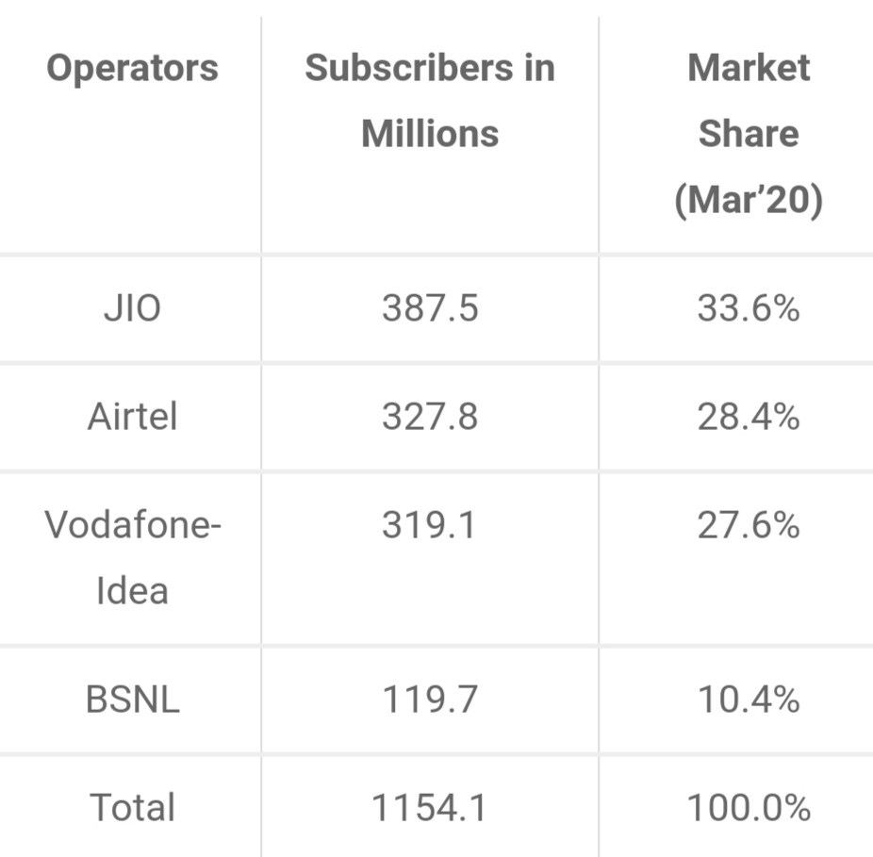

As we saw earlier that to create a category, we need to first freeze the target customer segment (Niche Market) and understand their requirements. **Focusing on a Niche Market**. The general rule is to start small. Smaller the segment, it is easier for the entire company to focus and meet the customer needs, wants and desires. Once you become a leader in the niche market, you could grow your market. **How to find a niche market?** A market exists when a customer has a problem that needs to be solved -Find and Focus on a particular need, work on it, make your product distinctive and dominate the niche market.

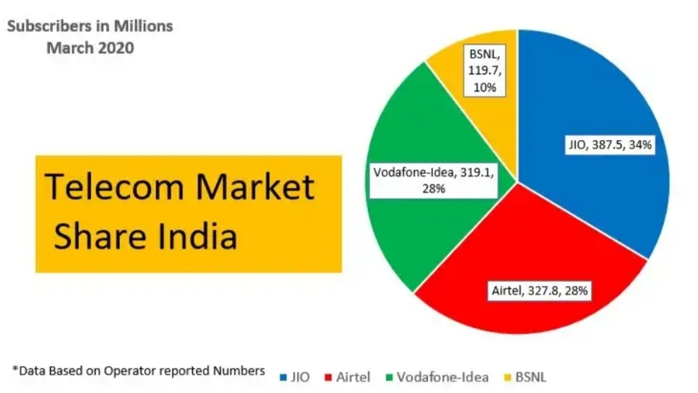

**SWOT ANALYSIS**

**Strengths**

* **Renowned Telecom company:** With its 19+ years of rich experience in telecom industry this MNC had travelled far to become world’s 3rd largest telecom operator overseas with [operations](https://www.marketing91.com/operational-decisions/) in nearly 20 countries.
* **High**[**Brand**](https://www.marketing91.com/what-is-a-brand/)**Equity:** It is one of the pioneer brands in telecommunication having a high [brand recall](https://www.marketing91.com/brand-recall/) and with a whopping subscriber base.
* **Extensive infrastructure:** With the formation of Indus tower & due to its partnership with Idea & [Vodafone](https://www.marketing91.com/swot-analysis-vodafone/), the infrastructure of Airtel has [extended](https://www.marketing91.com/extended-marketing-mix/) in all parts of the country resulting into nationwide penetration.
* **Strategic Alliances:** The company has top notch stakeholders, namely [Sony](https://www.marketing91.com/marketing-mix-sony/) Ericsson, [Nokia](https://www.marketing91.com/swot-nokia/) and SingTel, and the recent one being [Apple](https://www.marketing91.com/marketing-strategy-apple/). Such strategic alliances [boost](https://www.marketing91.com/marketing-mix-boost/) the [brand equity](https://www.marketing91.com/brand-equity/) and the bottom line of the company.
* **Torchbearer of the telecom Industry:** With its number 1 spot due to its excellent services in developing economies, Airtel has interconnected the life of [people](https://www.marketing91.com/people-marketing-mix/) in an highly efficient way. Thus, where Vodafone is an external entrant, Airtel is a leading nationwide player in India and the torchbearer of the telecom industry in India.

**Weakness**

* **Outsourced Operations:** [Outsourcing](https://www.marketing91.com/outsourcing/) operations helped Airtel in lowering its cost. But on the other hand, they are running the risk of being dependent on some other companies which may affect its operations.
* **Venturing into African operations:** Although it’s been 4 years that Airtel has acquired Zain’s Africa business, but Airtel is still struggling to turn around the unit which was bought at a whippy 9 billion dollars.
* **High Debt:** With its acquisitions turning out to bad investment, and credit being high and margins being low, Airtel group is under high debt. Airtel does not have as deep pockets as Vodafone.

**Threats**

1. **Government Regulatory Framework:**With the auction of spectrum & change in the government policies on a regular basis, it is a potential threat to the stability & existence of this industry thereby affecting the players.
2. **Competition:** Price war in the home market and declining margins due to this is adversely affecting the overall business of the group.
3. **MNP (Mobile number portability):** MNP gives the customer independence to change the service provider while retaining the number and as Airtel charges are premium over other service providers, it can see slump in subscriber base in the next fiscal year with PAN India MNP applicable from May 3rd 2015.

**Opportunities**

* **Strategic Partnership:** Partnering with smart phone companies is going to be a smart [strategy](https://www.marketing91.com/marketing-and-strategy-models-and-concepts/) as far as MNP (mobile number portability in India) is concerned. This will ensure fixed cash flows in the future and a higher customer base.
* [**Market**](https://www.marketing91.com/market/)[**Development**](https://www.marketing91.com/customer-development/)**:** With fierce competition in the telecom industry & shrinking margins, venturing out in new [markets](https://www.marketing91.com/types-of-market/)/developing economies will prove fruitful for the company.
* **VAS:** VAS (Value Added services) is going to future of the telecommunication industry & by specializing itself in this vertical Airtel can [differentiate](https://www.marketing91.com/differentiation-strategy/) itself in highly competitive market. With introduction of unique services, Airtel can avail higher margins.
* **Untapped geography of the current market:** Although it is currently providing 3G & 4G services, but these services are limited to specific geographical locations. Expansion of these services to most of its regions will help the company get more margins and customers.
* **LTE:** The whole wireless world is moving towards LTE (long term evolution or 4G). LTE for mobile broadband can be a good solution for India where fixed broadband penetration is otherwise low. Airtel has taken the lead with this version of LTE in 4 cities, but deployment [needs](https://www.marketing91.com/needs-wants-and-demands/) to catch up pace. Despite a weak LTE ecosystem in India, Airtel should portray itself as the embracer of that [technology](https://www.marketing91.com/how-to-make-your-business-more-efficient-by-upgrading-technology/). The company lacks nationwide 3G license with spectrum in 13 out of 22 telecom service areas. Airtel’s LTE network for mobile broadband is still confined to only 4 cities in India.

**CONCLUSION**

After analyzing the findings of the investigation, I can conclude that Airtel lagged behind its challengers as far as customer facility and availability is anxious. The maximum no. of people who use the mobile is in the age group of 20 to 28. Cash cards are the most popular type of mobile connections, as they are consumer friendly and recharging the connection is not a problem.

Maximum no. of people spends RS 500 on their connections. As Airtel is the only company having the highest no of mobile connections so it must critically look into the loop holes of the existing customer service department.

As we know that now Airtel has already launched its product with logo “Aisi azaadi aur kahan” has already became trendy in market. So, we can say that in malice of so many competitors in the market Airtel is having a good position just because every time, it tries its best to understand the need of its key customers.

From the evaluation and weighty analysis of every aspect of business of both the companies we can conclude that Bharti Airtel has to more work in every field of communication business.

It is the time not only to survive but to uphold in the market for a long time.

**REFRENCES:**

* 1. **https://en.wikipedia.org/wiki/Bharti_Airtel**
  2. **https://www.marketing91.com/airtel-competitors/**
  3. **https://www.ukessays.com/essays/marketing/the-organizational-structure-of-airtel-marketing-essay.php**
  4. [**https://shahmm.medium.com/brand-positioning-strategy-airtel-an-example-d870fa552d6d**](https://shahmm.medium.com/brand-positioning-strategy-airtel-an-example-d870fa552d6d)
  5. [**https://www.marketing91.com/swot-analysis-of-airtel/**](https://www.marketing91.com/swot-analysis-of-airtel/)